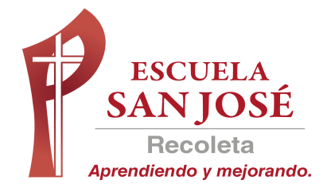
GUIA DE TRABAJO INGLES
RETROALIMENTACION DE LA EVALUACION FORMATIVA N°3
SEMANA 17 AL 21 DE AGOSTO
OCTAVO BASICO

OBJETIVO: IDENTIFICAR EL USO DE LOS PRONOMBRES POSESIVOS

REPASO DEL CONTENIDO DE LOS PRONOMBRES POSESIVOS

Actividad N°1: abre el siguiente ppt (Power Point)

(PARA ABRIR EL PPT UBIQUE EL CURSOR AL CENTRO DEL DIBUJO, DAR DOBLE CLICK Y ESPERAR UNOS SEGUNDOS PARA DESPLEGAR)

Actividad 1

Write the correct possessive pronoun: MINE, YOURS, HIS, HERS, ITS, OURS, THEIRS

E.g.: That car belongs to me. That car is mine. (Ese auto me pertenece. Ese auto es mío)
****BELONGS= PERTENECER

- That photograph belongs to them. That photograph is _____________________.

- That bracelet belongs to me. That bracelet is _____________________.

- This suitcase belongs to us. This suitcase is _____________________.

- These football boots belongs to him. These football boots are______________

- This computer game belongs to me and my brother. This computer game is _________________

- That motorbike belongs to that man. That motorbike is _____________________

- These books belong to those students. These books are ___________________

- This ipod belongs to you. This ipod is _____________________

- This camera belongs to my aunt. This camera is _____________________

- This ball belongs to those boys. This ball is _____________________.

- This scarf belongs to my Aunt Tina. This scarf is ______________

- This apartment belongs to my cousins. This apartment is ______________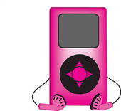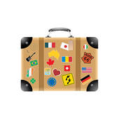



SOLUCIONARIO: la idea es que resuelvas los ejercicios por ti mismo (a) o con ayuda de un adulto y luego revises y corrijas si es necesario
- THEIRS
- MINE
- OURS
- HIS
- OURS
- HIS
- THEIRS
- YOURS
- HERS
- THEIRS
- HERS
- THEIRS

PRACTICA MAS EJERCICIOS EN LA PAGINA
https://agendaweb.org/grammar/possessive-pronouns-exercises.html
(RESUELVE LOS EJERCICIOS N°4, 5, 11 Y 16)

LA GUÍA LA PUEDES IMPRIMIR Y PEGAR O HACER EL DESARROLLO EN EL CUADERNO
NO SE ENVIA AL CORREO

LA GUÍA LA PUEDES IMPRIMIR Y PEGAR O HACER EL DESARROLLO EN EL CUADERNO

