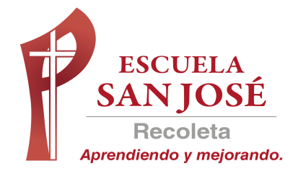
EVALUACION FORMATIVA
INGLES
SEMANA 25 AL 29 de Mayo
QUINTO BASICO
RESOLVER LA EVALAUACION Y ENVIAR SOLO LA HOJA DE RESPUESTAS AL CORREO lilian.bahamondez@laprovidenciarecoleta.cl

OBJETIVOS:
Escribir para dar información
Identificar palabras, frases clave y expresiones de uso frecuente.
Leer y demostrar comprensión de textos adaptados y auténticos simples

ITEM I LEE EL TEXTO Y RESPONDE TRUE (VERDADERO) O FALSE (FALSO) (5 P.)

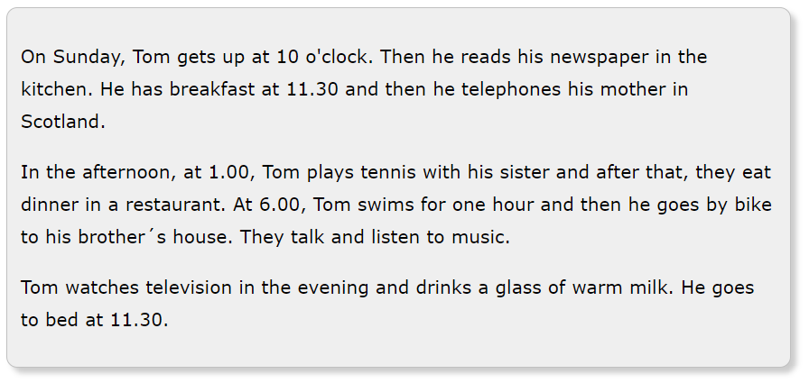

- ……………. Tom gets up at 10am on Sundays.
- ……………. Tom plays tennis with his sister.
- ……………. Tom goes swimming at five o'clock.
- ……………. Tom and his brother listen to music.
- ……………. Tom goes to bed at 11.30pm.

ITEM II OBSERVA EL HORARIO DE MARY Y RESPONDE LAS PREGUNTAS (5 P.)
USA ALWAYS – OFTEN – USUALLY – SOMETIMES - NEVER

 | Mon  Lun. | Tues  Mar. | Wed  Miér. | Thurs  Jue. | Fri  Vier. | Sat  Sáb. | Sun  Dom.
play video games | √ | √ | √ | √ | √ | √ | √
go to the library | √ | √ |  | √ | √
go to the park |  |  | √ |  |  | √
walk her dog |  |  |  | √ |  |  | √
watch TV
Study History |  | √ | √ | √

Example: How often does Mary study History? Often

(¿Con qué frecuencia Mary estudia Historia?)

- How often does Mary play video games? …………………………
- How often does Mary go to the library? …………………………
- How often does Mary go to the park? …………………………
- How often does Mary walk her dog? …………………………
- How often does Mary watch TV? …………………………

ITEM III OBSERVA LAS IMÁGENES Y ESCRIBE LA ORACION CORRECTA (6 PTS.)

DO THE DISHES – HAVE DINNER – TIDY MY ROOM – WALK THE DOG
DO MY HOMEWORK – SEE MY FRIENDS



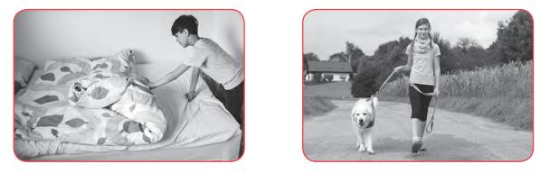
- ………………………………………. 2. ………………………………………….

3……………………………………….. 4…………………………………………….



5……………………………………… 6………………………………………….

ITEM IV ESCRIBE EL NUMERO EN LA HORA CORRECTA (5 PTS.)
1. It’s three o’clock. |  | a. 10.35
2. It’s a quarter past eight. |  | b. 8.05
3. It’s five past eight. |  | c. 4.55
4. It’s five to five. |  | d. 3.00
5. It’s twenty-five to eleven. |  | e. 8.15

ITEM V ESCRIBE LA HORA CON NÚMEROS (5 PTS.)
- It’s ten past eleven-…………………….
- It’s five to ten - ………………………….
- It’s a quarter to three- …………………
- It’s a quarter past three - ……………..
- It’s twelve o’clock - …………………….

HOJA DE RESPUESTA

Nombre:
Curso: | 5° ____ PUNTAJE TOTAL 26 PTS.

ITEM I RESPONDE TRUE (VERDADERO) O FALSE (FALSO) (5 P.)

1..
2.
3.
4.
5.

ITEM II RESPONDE LAS PREGUNTAS (5 P.)
USA ALWAYS – OFTEN – USUALLY – SOMETIMES - NEVER

1..
2.
3.
4.
5.

ITEM III ESCRIBE LA ORACION CORRECTA (6 PTS.)

1..
2.
3.
4.
5.
6.

ITEM IV ESCRIBE LA NUMERACION CORRECTA (5 PTS.)

ITEM V ESCRIBE LA HORA CON NÚMEROS (5 PTS.)

1..
2.
3.
4.
5.

