
EVALUACION FORMATIVA
INGLES
SEMANA 25 AL 29 de Mayo
CUARTO BASICO
RESOLVER LA EVALAUACION Y ENVIAR SOLO LA HOJA DE RESPUESTAS AL CORREO lilian.bahamondez@laprovidenciarecoleta.cl

OBJETIVOS:
Leer y demostrar comprensión de textos, identificando vocabulario y expresiones de uso frecuente
Leer y aplicar estrategias para apoyar la comprensión; por ejemplo: establecer relaciones con conocimientos previos

ITEM I LEE Y MARCA LOS OBJETOS QUE ESTÁN EN EL TEXTO (5 PTS.)

Hello, my name is Martha and I am 8 years old. I go to a school called Saint Julian’s. I am in 3rd grade in Primary level. In our class there are 37 students.
My classroom is big and nice. Our teacher is Miss Rachel and she likes decorating the walls of the class with posters. In our class there is a computer and a board.
My table and my chair are brown. On my table I have my pencil case. In my pencil case I have many things: a red sharpener, two pencils, a rubber, three markers, a glue and a purple pen.
I go to school by bus with my best friend Tina. We like our school because It’s big and nice





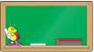




ITEM II LEE EL TEXTO Y RESPONDE TRUE (VERDADERO) O FALSE (FALSO) (5 P.)
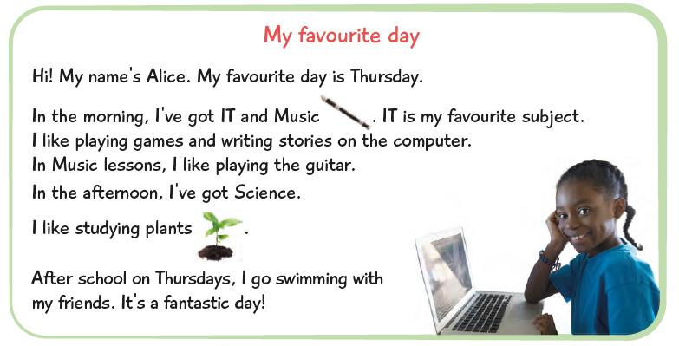

- …………… Alice’s favorite day is Tuesday.
- …………… Her favorite subject is IT.
- …………… She’s got Music in the afternoon.
- …………... She doesn’t like playing the guitar.
- ………….. She likes studying plants.
- ………….. After school, she goes to the tennis club.

ITEM III OBSERVA EL HORARIO ESCOLAR Y RESPONDE LAS PREGUNTAS (6 PTS.)
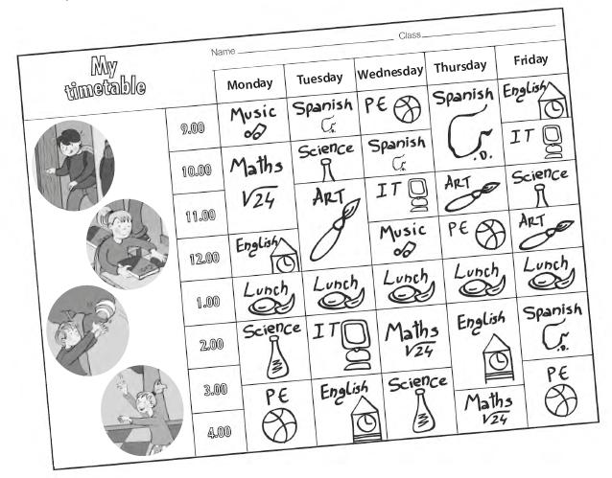

- What have you got on

- What have you got on Friday at 12:00? ………………………………….
- What have you got on Monday at 2:00? ………………………………….
- What have you got on Tuesday at 9:00? ………………………………….
- What have you got on Thursday at 4:00? ………………………………….
- What have you got on Wednesday at 10:00? ………………………………….
- What have you got on Friday at 2:00? ………………………………….

ITEM IV OBSERVA EL HORARIO ANTERIOR Y COMPLETA LAS ORACIONES CON LA SIGNATURA (6 PTS.)

- I’ve got …………………….on Monday at 10:00.
- I’ve got …………………….on Tuesday at 2:00.
- I’ve got …………………….on Wednesday at 9:00.
- I’ve got …………………….on Thursday at 9:00.
- I’ve got …………………….on Friday at 10:00.
- I’ve got …………………….on Monday at 12:00.

HOJA DE RESPUESTA

Nombre:
Curso: | 4° ____ PUNTAJE TOTAL 22 PTS.

ITEM I ESCRIBE EL NOMBRE DE LOS OBJETOS QUE APARECEN EN EL TEXTO (5 P.)

1..
2.
3.
4.
5.

ITEM II RESPONDE TRUE O FALSE (5 P.)

1..
2.
3.
4.
5.

ITEM III RESPONDE LAS PREGUNTAS (6 PTS.)

1..
2.
3.
4.
5.
6.

ITEM IV COMPLETA LAS ORACIONES CON LA SIGNATURA (6 PTS.)

1..
2.
3.
4.
5.
6.

