

INGLES
LILIAN BAHAMONDEZ CANDIA

EVALUACION DIAGNOSTICO 2020
Nombre:
Curso: | 6 A - B
Fecha:

_

RUT DEL ESTUDIANTE

INDICACIONES

- Realicen la prueba en silencio
.
- Tienen 60 minutos para realizar la prueba.

- Traspase las respuestas a la hoja de respuestas

OBJETIVOS:

- Leer comprensivamente textos no literarios identificando información explicita (OA6)

- Identificar en los textos escuchados: tema e ideas generales; información específica asociada a personas, lugares y tiempo (OA2)

- Escribir para dar información sobre un tema conocido (OA15)

Puntaje ideal : 34 | Puntaje: Obtenido: _________

- READ THE FOLLOWING TEXT ABOUT ANTONIO. WRITE TRUE OR FALSE (5 PTS.)
Hi, my name is Antonio. I am 10 years old. I live in La serena. My favorite activities are singing and playing with my Friends, they’re very nice, sometimes we watch movies.
There are five people in my family. I have two sisters, a baby brother and a mother. My mother’sname is Fabiola, she is very funny and intelligent. She helps me with math and science. I don’t really like those subjects!!

- ………………… Antonio is 10 years old.
- ………………… He lives in Santiago.
- ………………… He likes playing sports.
- ………………… Antonio’s Friends are silly and bored.
- ……………….. There are 7 people in his family.

- READ THE TEXT ABOUT THREE RESTAURANTS AND ANSWER THE QUESTIONS (4 PTS.)


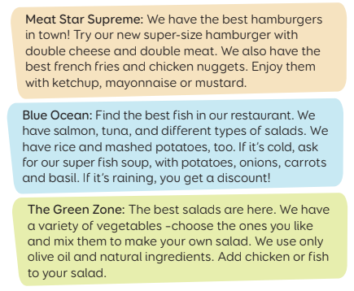

- Which restaurant do you prefer? Why?................................................
- In which restaurant can you buy french fries?......................................
- In which restaurant can you have soup?..............................................
- Which restaurants are the healthiest?...................................................

- COMPLETE THE PROFILE WITH YOUR INFORMATION (6 PTS.)

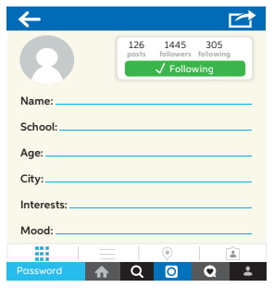

- LOOK AT THE MAP AND WRITE SENTENCES DESCRIBING LOCATIONS. USE THE PREPOSITIONS OF PLACE (4 PTS.)
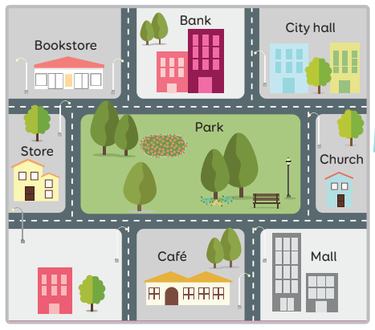

- ……………………………………………………………………………….

- ……………………………………………………………………………….

- ……………………………………………………………………………….

- ………………………………………………………………………………..

- WRITE A RECIPE (8 PTS.)

RECIPE FOR…………………………..
INGREDIENTS
- ……………………….

- ……………………….

- ……………………….

- ……………………….
PREPARATION

……………………………………………….

……………………………………………….

……………………………………………….

………………………………………………..

- LISTEN TO 4 PEOPLE TALKING ABOUT THEIR FAMILIES. THEN ORDER THESE PICTURES AS THEY ARE MENTIONED BY WRITING A NUMBER (1-4) IN THE SPACE PROVIDED (4 PTS.)

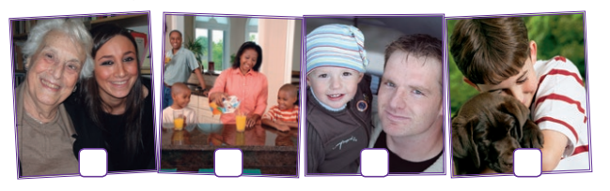

- LISTEN TO THE PEOPLE TALKING. HOW DO THEY FEEL? CIRCLE THE ANSWER (3 PTS.)



HOJA DE RESPUESTA

Nombre:
Curso: | 6° ____ Ptje: Obtenido: _________34

ITEM 1 TRUE OR FALSE (5 ptos.)

A
B
C
D
E

ITEM 2. ANSWER THE QUESTIONS (4 PTS.)
A.
B.
C.
D.

ITEM 3. COMPLETE THE PROFILE (6 PTS.)

NAME
SCHOOL
AGE
CITY
INTERESTS
MOOD

ITEM 4 WRITE SENTENCES DESCRIBING LOCATIONS (4 PTS.)
1..
2.
3.
4.

ITEM 5 WRITE A RECIPE (8 PTS.)

RECIPE FOR…………………………..
INGREDIENTS
- ……………………….

- ……………………….

- ……………………….

- ……………………….
PREPARATION

……………………………………………….

……………………………………………….

……………………………………………….

………………………………………………..

ITEM 6 WRITE THE NUMBER IN ORDER (4 PTS.)

ITEM 7 WRITE THE CORRECT ANSWER (3 PTS.)

PERSON 1
PERSON 2
PERSON 3

