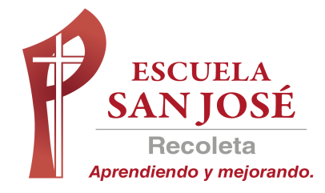

INGLES
LILIAN BAHAMONDEZ CANDIA

EVALUACION DIAGNOSTICO 2020
Nombre:
Curso: | 8 A - B
Fecha:

_

RUT DEL ESTUDIANTE

INDICACIONES

- Realicen la prueba en silencio
.
- Tienen 60 minutos para realizar la prueba.

- Traspase las respuestas a la hoja de respuestas

OBJETIVOS:

- Demostrar comprensión de textos no literarios identificando ideas generales, información específica y detalles. (OA10)
-Demostrar comprensión de ideas generales e información explícita en textos orales adaptados y auténticos simples. (OA1)
- Demostrar conocimiento y uso del lenguaje. (OA16)

Puntaje ideal : 37 | Puntaje: Obtenido: _________

READ THE TEXT
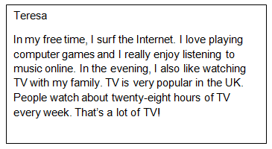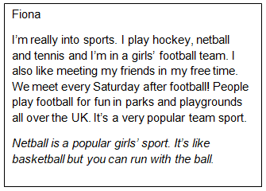
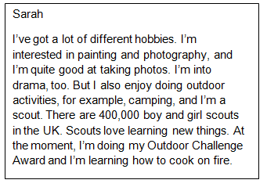

1. WRITE THE NAME OF THE GIRL (3 PTS.)
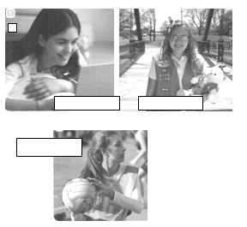
2. WRITE TRUE OR FALSE (6 PTS.)
A. ………………………Teresa practices sports in her free time.
B. …………………….. Fiona is interested in computer games.
C. ……………………. Football is a very popular team sport in UK.
D. ……………………. Teresa is a girl scout in UK.
E. ……………………. Sarah loves outdoors activities.
F. …………………… Peple love watching TV in UK.

3. WRITE SENTENCES USING YOUR OWN IDEAS AND THE WORDS IN THE BOX (5 PTS.)
Like love dislike hate prefer

- I …………………………………………………………….

- I …………………………………………………………….

- I …………………………………………………………….

- I ……………………………………………………………..

- I ……………………………………………………………..

4. CHOOSE THE CORRECT ANSWER IN PRESENT SIMPLE. (5 PTS.)
1. We ………………………… in a big city.
a) don’t live b) not live
2. Our clases ………………………at a quarter past three.
a) finish b) finishes
3. Sylvia …………………………..her new school.
a) don’t like b)doesn’t like
4. You ……………………………….the housework everyday.
a) aren’t do b)don’t do
5. I ………………………………….toast and coffee for breakfast.
a) have b) has

5. CIRCLE THE CORRECT OPTION (5 PTS.)
A. Could / Would like to come to my birthday party?
B. Do I need to / should bring anything?
C. Need / Could you bring some chips and soda?
D. Could / Would I bring a friend?
E. You need to / would tell me if you can come.

6. LISTEN AND NUMBER THE PICTURES (4 PTS)
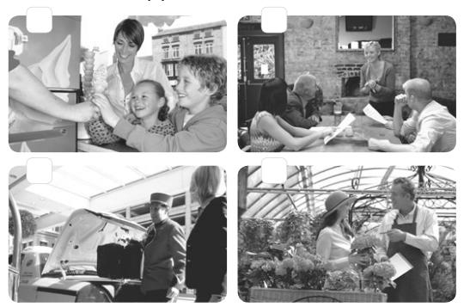
7. LISTEN AGAIN. MATCH THE PEOPLE TO WHAT THEY SAY (4 PTS.)
- Ice-cream seller ………..Do you need any help? Are you
looking for something special?

- Server in the restaurant ………..Hi.My name is Sally. Can I take Your order?
c. Hotel porter ……….Would you like some help?
d. Assistant in plant store ……….May I help you?

HOJA DE RESPUESTA

Nombre:
Curso: | 8° ____ Ptje: Obtenido: _________37

ITEM 1 WRITE THE NAMES ( 3 ptos.)

A
B
C

ITEM 2. WRITE TRUE OR FALSE (6 ptos.)

A.
B.
C.
D.
E.
F.

ITEM 3. WRITE YOUR OWN IDEAS (5 PTS.)

A.
B.
C.
D.
E.

ITEM 4 WRITE THE CORRECT ANSWER (5 PTS.)
1..
2.
3.
4.
5.

ITEM 5 WRITE THE CORRECT OPTION (5 PTS.)

A.
B.
C.
D.
E.

ITEM 6 WRITE THE CORRECT OPTION (5 PTS.)

A.
B.
C.
D.
E.

ITEM 7 WRITE THE CORRECT LETTER (4 PTS.)

A.
B.
C.
D.

